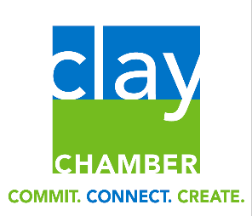
Clay County Chamber of Commerce in partnership with Defense Acquisition Professionals Alumni Association, Jax FL Chapter is proud to ask for your support of the
2022 Clay County
HS Scholarship Program
- The program is open to all HS seniors in Clay County
- Donation, benefits, and payment information below
- All donations come with W9 and receipt
- Access application at www.dapaajax.org
- All scholarships are for $1,000
- $2,500 (Gold) | $350 and below plus,  - 2 tickets to July 9 (Saturday) Jumbo Shrimp (where all scholarship winners will be attending)  - Sponsor sign at both DAPAA golf events  - Personal visit with your sponsored winner for a meet & greet | - $350 | - Listed on Clay Chamber & DAPAA Website  - Listed in News Article in Clay Today  - Sponsor sign at Clay Chamber golf event
- $2,000 (Silver) |  | - $300
- $1,500 (Bronze) |  | - $250
- $1,000 (Red) |  | - $200
- $750 (White) |  | - $100
- $500 (Blue) |  | - $50

Contact Duane Mallicoat at duanemalli@comcast.net or Dana Heisler at dheisler@claychamber.com Make payment onlinewww.dapaajax.org
Name:___________________________Email:__________________________________
Street Address:______________________________ City/State/Zip:_________________
All major credit cards accepted or make checks payable to DAPAA and mail to
2271 Trailwood Drive, Flaming Island FL 32003

